LAB REPORT 05
Discrete-Time Systems & Laplace Transforms
Exercise 01: Discrete-Time System Frequency & System Response
Suppose that a discrete-time system is described by the frequency response:
H(ω) = (4 + 2e^(-2jω)) / (3 + 5e^(-jω))
Plot the frequency response H(ω). Also, compute and plot the system response to the discrete-time input signal:
x[n] = 2cos(4n + π/6)
Numerical Outputs:
• H(4): -0.589430 - 0.938397j
• Magnitude |H(4)|: 1.108159
• Phase ∠H(4): -2.131640 radians
• Output Amplitude (A): 2.216318
• Output Phase (φ): -1.608041 radians
MATLAB Implementation Code:
clc;
clear;
close all;

%% Part 1: Frequency Response H(w)
% Define frequency range
w = linspace(-pi, pi, 2000);

% Define system frequency response
H = (4 + 2*exp(-1j*2*w)) ./ (3 + 5*exp(-1j*w));

% Plot Magnitude and Phase Response
figure(1);

subplot(2,1,1);
plot(w, abs(H), 'b', 'LineWidth', 1.5);
grid on;
xlabel('Frequency (rad/sample)');
ylabel('|H(w)|');
title('Magnitude Response');

subplot(2,1,2);
plot(w, unwrap(angle(H)), 'r', 'LineWidth', 1.5);
grid on;
xlabel('Frequency (rad/sample)');
ylabel('Phase (radians)');
title('Phase Response');

%% Part 2: System Response to Input x[n]
% Time index and input signal parameters
n = 0:40;
x = 2 * cos(4*n + pi/6);
w0 = 4;

% System response at frequency w0 = 4
H0 = (4 + 2*exp(-1j*2*w0)) / (3 + 5*exp(-1j*w0));

% Output magnitude and phase
A = 2 * abs(H0);
phi = pi/6 + angle(H0);

% Compute output signal y[n]
y = A * cos(w0*n + phi);

% Display numerical results
fprintf('H(4) = %.6f + %.6fj\n', real(H0), imag(H0));
fprintf('Magnitude of H(4) = %.6f\n', abs(H0));
fprintf('Phase of H(4) = %.6f radians\n', angle(H0));
fprintf('Output amplitude = %.6f\n', A);
fprintf('Output phase = %.6f radians\n', phi);

% Plot Input and Output signals
figure(2);

subplot(2,1,1);
stem(n, x, 'filled', 'b');
grid on;
xlabel('n');
ylabel('x[n]');
title('Input Signal x[n]');

subplot(2,1,2);
stem(n, y, 'filled', 'r');
grid on;
xlabel('n');
ylabel('y[n]');
title('Output Signal y[n]');
Simulation Output Plot:
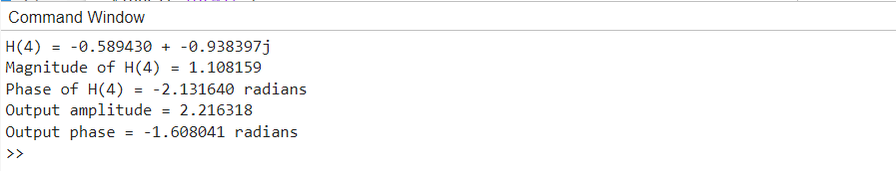

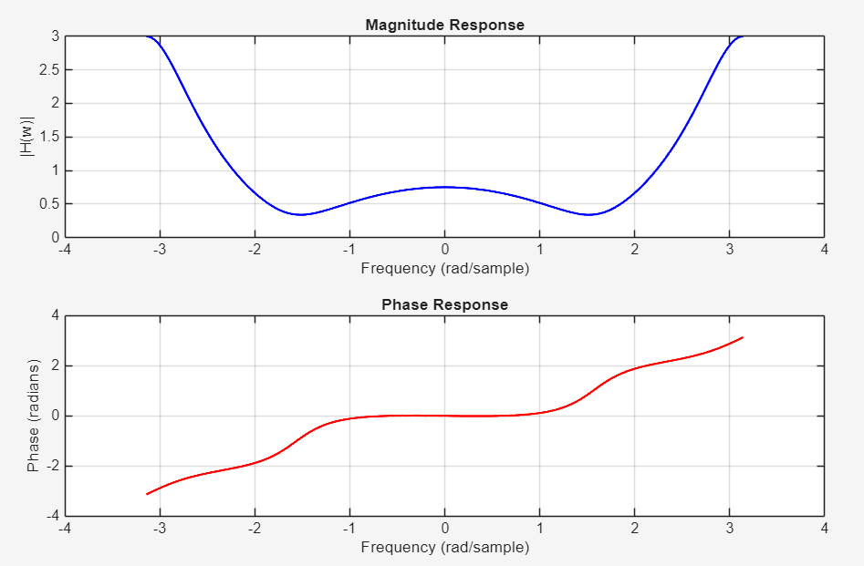

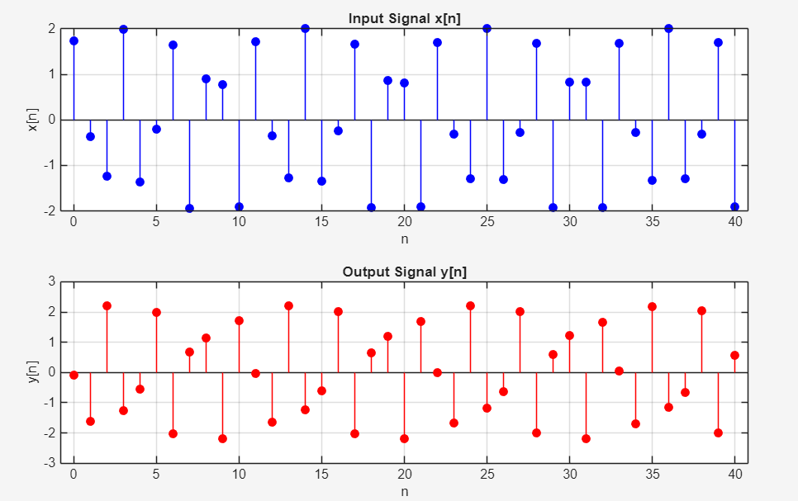

Exercise 02: Unilateral Laplace Transform
Compute the unilateral Laplace transform of the following functions:
- 2(a): δ(t)
- 2(b): u(t)
- 2(c): e^(-3t)u(t)
- 2(d): cos(2πt)u(t)
Analytical Results:
• 2(a) ℒ{δ(t)}: 1
• 2(b) ℒ{u(t)}: 1 / s
• 2(c) ℒ{e^(-3t)u(t)}: 1 / (s+3)
• 2(d) ℒ{cos(2πt)u(t)}: s / (s² + 4π²)
MATLAB Implementation Code:
clc;
clear;
close all;

% Define symbolic variables
syms t s

% 2(a): Laplace Transform of Dirac delta function
f1 = dirac(t);
F1 = laplace(f1, t, s);

% 2(b): Laplace Transform of Heaviside step function u(t)
f2 = heaviside(t);
F2 = laplace(f2, t, s);

% 2(c): Laplace Transform of exp(-3t)*u(t)
f3 = exp(-3*t) * heaviside(t);
F3 = laplace(f3, t, s);

% 2(d): Laplace Transform of cos(2*pi*t)*u(t)
f4 = cos(2*pi*t) * heaviside(t);
F4 = laplace(f4, t, s);

% Display results
disp('2(a):'); disp(F1);
disp('2(b):'); disp(F2);
disp('2(c):'); disp(F3);
disp('2(d):'); disp(F4);
Simulation Output Plot:


